Name: MITHUN MARAGIRI

Course: EE450

Session #: 2

Assignment: OPNET RIP

**ABSTRACT**

The purpose of this report is to discuss the laboratory assignment for the course EE-450 Introduction to Computer Networks. The assignment is to simulate RIP (Routing Information Protocol) environment with real-time networks and protocols. The labs have been deployed in Riverbed Modeler Academic simulation environment. The simulation in this lab will help examine the performance of RIP for Traffic Received (bits/sec), Traffic Sent (bits/sec) and Routing Table total number of updates.

The assignment consists of simulation of 3 scenarios: No_Failure, Failure and OSPF_Ping. The analysis of the experiment results are done for a simulation time of 10 minutes with IP Dynamic Routing Protocol = RIP, IP Interfacing Addressing Mode = Auto Address/Export and RIP Simulation Efficiency = Disabled.

**INTRODUCTION**

Riverbed Modeler Academic Edition offers all the tools for network model design, simulation and analysis of the experiment results. Riverbed Modeler can simulate a wide variety of different networks. The laboratory has been designed to simulate Routing Information Protocol. Through this lab, we get to learn how to use Rapid Configuration Tool for setting up topology with 4 routers and each connected to LANs, the different options available while setting up a network, the simulation parameters, comparing the results from different scenarios, the design of network simulation for performance evaluation.

**GRAPHS**

* **Object Statistics ->Total Number of Updates -> Bar Charts**

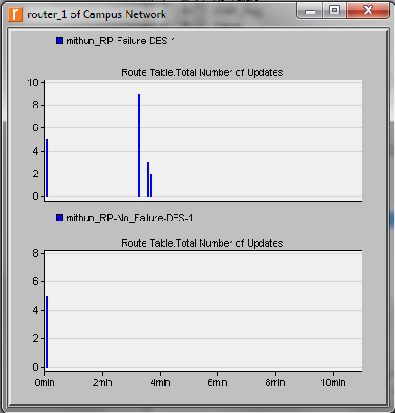

* **Ping Report**

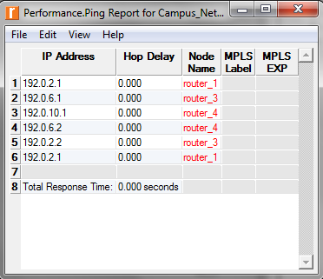

* **IP Assignment**

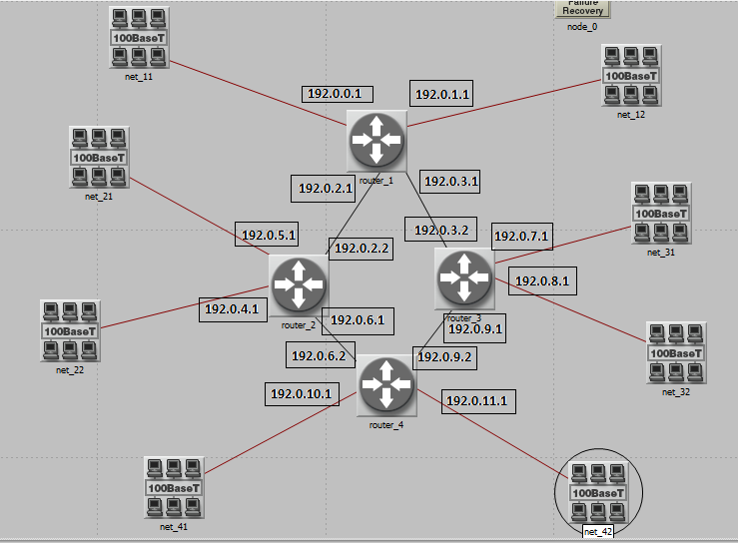

* **Forwarding Table for Router 1 in No_Failure scenario**

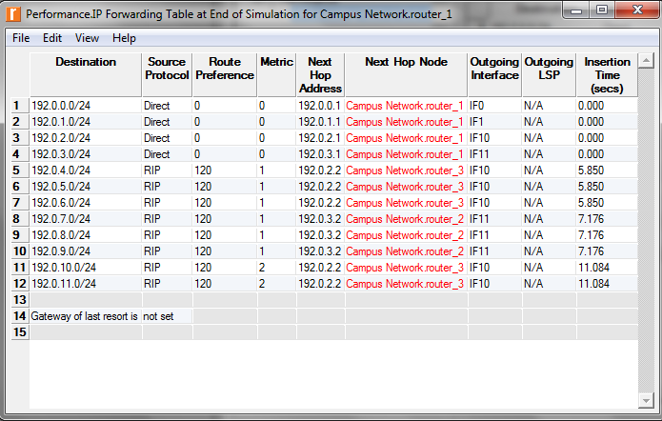

* **Forwarding Table for Router 1 in Failure scenario**

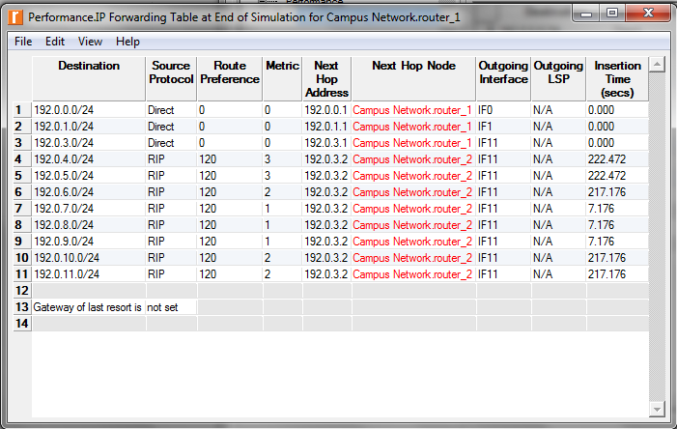

**EXERCISE**

1. Obtain and Analyze the graphs that compare the sent RIP traffic for the failure and NO failure scenario. Make sure to change the draw style for the graphs to Bar

Ans: The graphs are presented above. In No failure scenario, it shows that routing table we created will build their routing table with no update tables as there is no link failure therefore, the routing table is smooth as shown in the above figure. In Failure scenario, we created a link failure where more traffic is sent and configured the duration to fail the simulation. In result the RIP in effected nodes send out an update of their routing table to place that failure.

1. Describe and explain the effect of the failure of the link connecting Router1 to Router2

on the routing tables of Router1.

Ans: In our simulation, the two routers will detect the link failure between Router1 and Router2, these routers are ends of the failed link. Each of these two routers, starts sending updates to their connected neighbours: Router1 sends update at 200 sec (time of failure) to Router4 then Router4 sends update to Router3, which in its turn sends update to Router2. Router2 sends updates at 200 sec (time of failure) to Router3 then Router3 sends

an update to Router4, which in its turn sends update to Router1. So, each of Router1 and Router2 will generate an update and receive another caused by the same topology change. This behaviour appears in the graph, as two bars one at the time of failure (200 sec) and the other when the update is received later in some seconds (at 215 sec).

1. Create another scenario as a duplicate of the Failure scenario. Name the new scenario Q3_Recover. This new scenario has the link connecting Router1 to Router2 recover after 400 s. (Make sure to keep the failure that occurs at the 200th second.) Generate and analyze the graph that shows the effect of this recovery on the Total Number of Updates in the routing table of Router1 . Check the contents of Router1's routing table. Compare this table with the corresponding routing tables generated in the NO_Failure and Failure scenarios.

Ans:

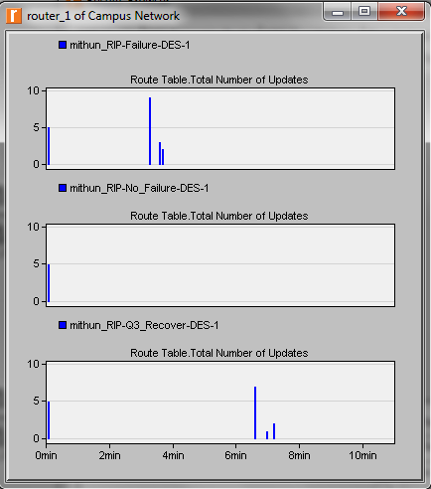

It can be seen that the Total number of updates have increased when the link between R1 and R2 recovers after 400 sec.

Forwarding table comparison for the 3 scenarios:

Q3_Recover Scenario

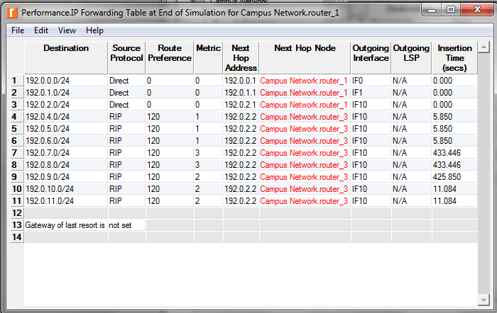

No Failure Scenario



Failure Scenario



1. Change the Ping packet size to 5000 bytes. (Hint: Edit the attributes of the Ping Parameters node.) Run the simulation to generate a new Ping report. What is the effect of the new size on the ICMP packet response time?

Ans: Ping Report

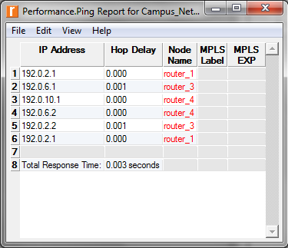

With the increase in ICMP packet size the ICMP Packet response time also increases.

**RESULTS**

We have studied the 5 cases: No_Failure, Failure, ICMP_Ping, Q3_Recover and ICMP_Ping with 5000 bytes ICMP packet size. we studied the effect of link failure and recovery on the number of sent RIP. In RIP updates are exchanged at startup and triggered on topology change, during stable periods no routing updates are exchanged.

**Riverbed Modeler Experience**

The tool is very much user friendly and has easy to use graphical user interface. The assignment description document has detailed explanation about the configuration and the procedure for conducting the lab. The usage to the tool gave an understanding of how to simulate Routing Information Protocol, the various components needed to setup the topology, the performance measures for each of these scenarios. The installation of the tool is also very simple and straightforward. The tool is scalable to great extent. If we want to update the network scenario we can do it without rebuilding entire thing from scratch. OPNET modeller lets us analyze realistic simulated networks to compare the impact of different technology designs on end to end behaviour.